***Finance Analytics :***

**Q1.Croma India Product wise sales Report for fiscal year 2021.**

Note :- (month = Date )

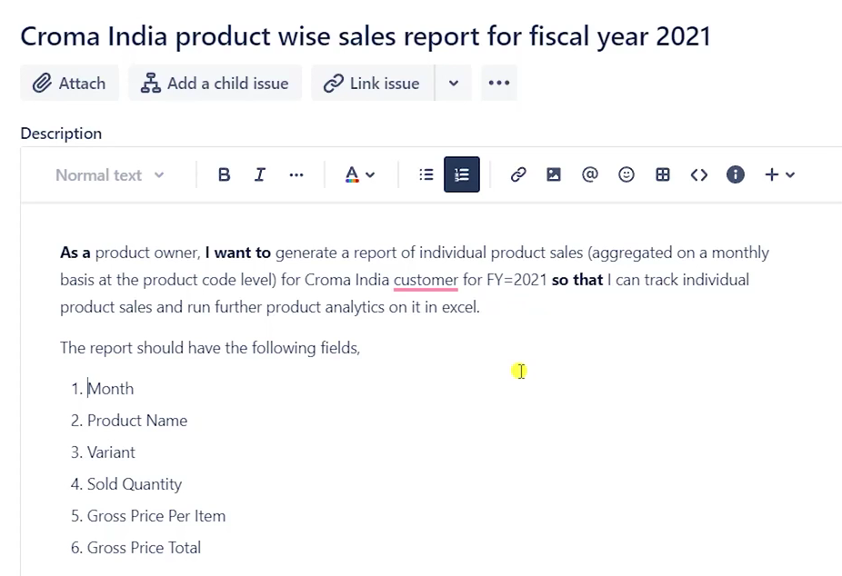

with cte as (

SELECT * FROM fact_sales_monthly as Fsm

where Fic_yr_from_cal_year(date) = 2021 and customer_code = "90002002"

)

select date,dp.product_code,dp.product, dp.variant,sold_quantity,

g.gross_price, round((sold_quantity*

g.gross_price),2) as total_gross_price

from cte

join dim_product as dp

using(product_code)

join fact_gross_price as g

on (cte.product_code = g.product_code

and Fic_yr_from_cal_year(cte.date) = g.fiscal_year)

where cte.product_code = "A0118150102"

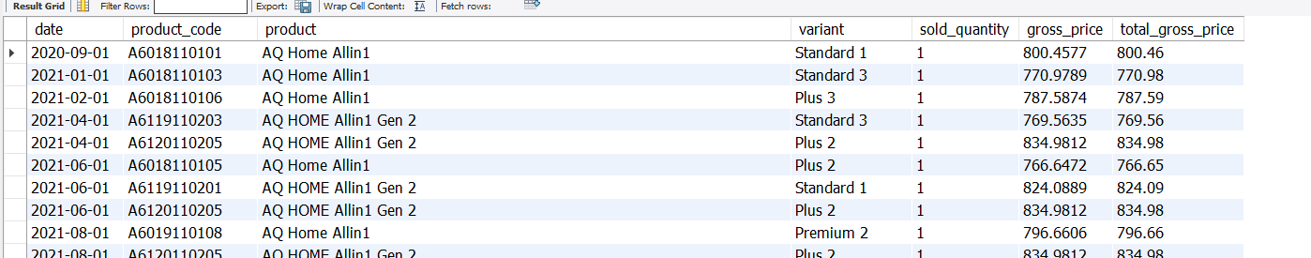

**Q2.Gross Sales monthly Total Sales Report for Croma :-**

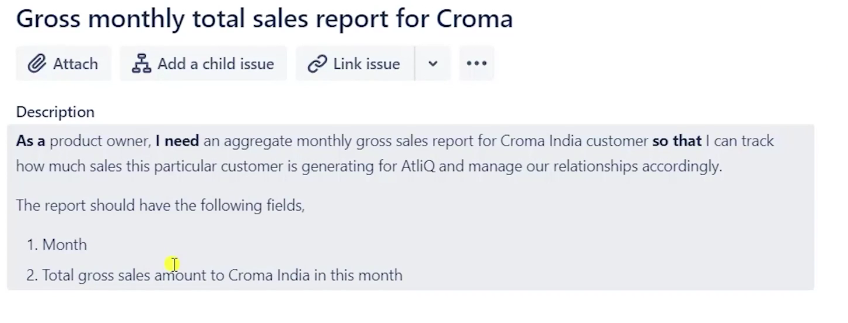

with cte as (SELECT * FROM gdb0041.fact_sales_monthly where customer_code = "90002002")

select cte.date,

round(sum((g.gross_price*cte.sold_quantity)),2) as total_gross_sales

from cte join fact_gross_price as g

on Fic_yr_from_cal_year(date) = g.fiscal_year

and cte.product_code = g.product_code

group by cte.date

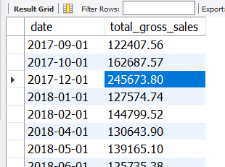

Q3. Generate a yearly report for Croma India where there are two columns

1. Fiscal Year  
2. Total Gross Sales amount In that year from Croma

with cte as (SELECT * FROM gdb0041.fact_sales_monthly where customer_code = "90002002")

select cte.fic_year , round(sum(cte.sold_quantity * g.gross_price),2) as total_sales_qty

from cte join fact_gross_price as g

on cte.fic_year = g.fiscal_year

and cte.product_code = g.product_code

group by cte.fic_year

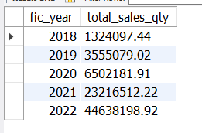

Q4.Stored Procedures

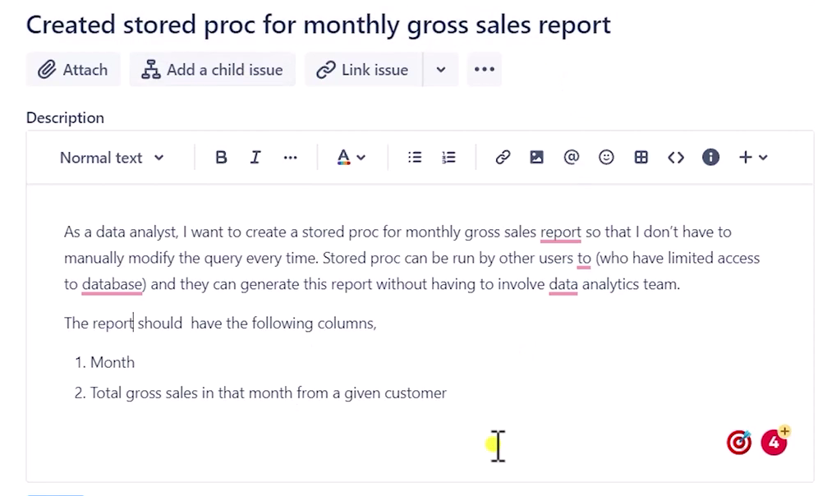

CREATE DEFINER=`root`@`localhost` PROCEDURE `new_Montly_stored_procedure`(

c_code int)

BEGIN

with cte as (

SELECT * FROM gdb0041.fact_sales_monthly where customer_code = c_code

)

select cte.date,

round(sum((g.gross_price*cte.sold_quantity)),2) as total_gross_sales

from cte join fact_gross_price as g

on Fic_yr_from_cal_year(date) = g.fiscal_year

and cte.product_code = g.product_code

group by cte.date;

END

Q5. Stored Procedure for Market Badge :-

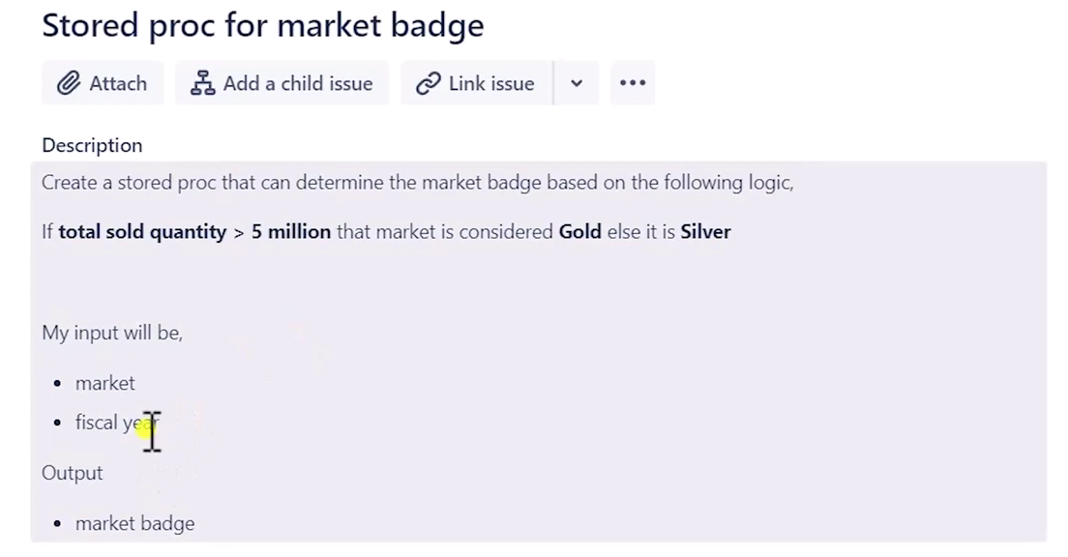

CREATE DEFINER=`root`@`localhost` PROCEDURE `Market_badge`(

g_year int,

g_market text,

out market_badge text

)

BEGIN

declare qty int default 0;

# set the default market

if g_market = "" then

set g_market = "india";

end if;

# get the total qty

SELECT round(sum(fsm.sold_quantity)/1000000,2) into qty

FROM gdb0041.fact_sales_monthly as fsm

left join dim_customer as dc

using(customer_code)

where fsm.fic_year = g_year and dc.market = g_market

group by dc.market;

# set the market badge

ifqty > 5 then

set market_badge = "Gold";

else

set market_badge = "Silver";

end if;

END

Q6. Top Market, Product, Customers for the Given Finance year :-

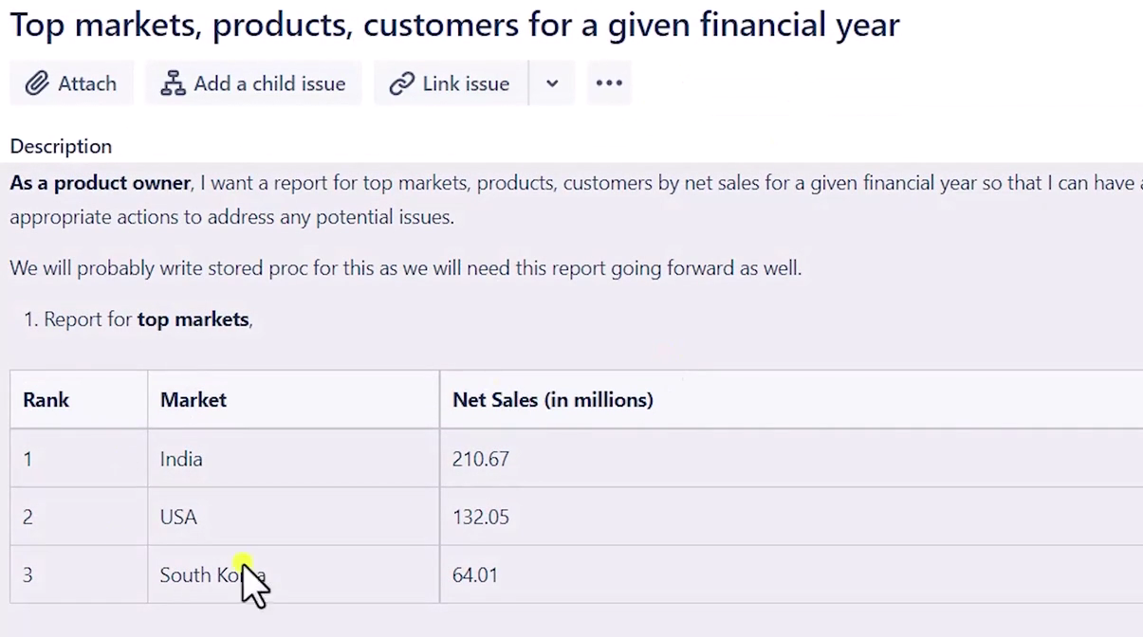

Step :-1 create a view

create view Net_Sales as

with Gross_sales as (

SELECT fsm.date,fsm.fic_year,fsm.product_code,fsm.customer_Code,

round((fsm.sold_quantity*fgp.gross_price),2) as Gross_sales

FROM fact_sales_monthly fsm

join fact_gross_price as fgp

on fsm.fic_year = fgp.fiscal_year

and fsm.product_code = fgp.product_code

where fsm.fic_year = 2021

)

,

Net_invoice_sales as

(

select gs.*,

round(Gross_sales - (fpid.pre_invoice_discount_pct*Gross_sales),2) as Net_invoice_sales

from Gross_sales as gs

join fact_pre_invoice_deductions as fpid

on gs.customer_Code = fpid.customer_code

and gs.fic_year = fpid.fiscal_year

)

select

nis.product_code,nis.customer_code,

dc.market,

round(Net_invoice_sales - ((Net_invoice_sales*pst.discounts_pct)+

(Net_invoice_sales*pst.other_deductions_pct)),2) as Net_sales

from Net_invoice_sales as nis

join fact_post_invoice_deductions as pst

on nis.customer_code = pst.customer_code

and nis.product_code = pst.product_code

and nis.date = pst.date

join dim_customer as dc

on dc.customer_code = nis.customer_code

Q6.1 ***Top Market based on Net Sales.***

**Create the Stored Procedure** For Market .

CREATE DEFINER=`root`@`localhost` PROCEDURE `top_markets_by_net_sales`(

in_fic_year int,

int_limit int

)

BEGIN

SELECT market,

round((sum(net_sales)/1000000),2) as "total_net_sales_amount"

FROM gdb0041.net_sales

where fic_year = in_fic_year

group by market

order by total_net_sales_amount desc limit int_limit;

END

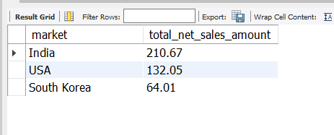

Q6.2 ***Top Customer based on Net Sales.***

Create the Stored Procedure for Customer.

CREATE DEFINER=`root`@`localhost` PROCEDURE `top_customer_by_net_Sales`(

in_fic_year int,

top_N int

)

BEGIN

SELECT customer,

round((sum(net_sales)/1000000),2) as "total_net_sales_amount"

FROM gdb0041.net_sales

where fic_year = in_fic_year

group by customer

order by total_net_sales_amount desc limit top_N;

END

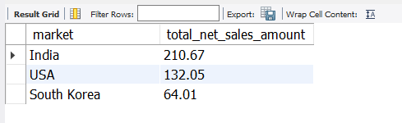

Q6.3 ***Top Products based on Net Sales.***

Create the Stored Procedure for Customer.

CREATE DEFINER=`root`@`localhost` PROCEDURE `top_n_products_by_net_Sales`(

in_fic_year int,

top_N int

)

BEGIN

SELECT product,

round((sum(net_sales)/1000000),2) as "total_net_sales_amount"

FROM gdb0041.net_sales

join dim_product as dp

using(product_code)

where fic_year = in_fic_year

group by product

order by total_net_sales_amount desc limit top_N;

END

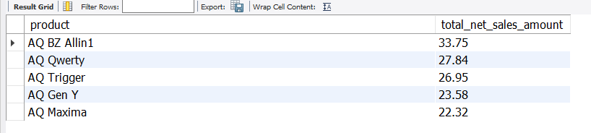

Q7. Net Sales % share by Region and customer in the year 2021

*Step :- 1 Creating a view*

create view Net_Sales as

with Gross_sales as (

SELECT fsm.date,fsm.fic_year,fsm.product_code,fsm.customer_Code,

round((fsm.sold_quantity*fgp.gross_price),2) as Gross_sales

FROM fact_sales_monthly fsm

join fact_gross_price as fgp

on fsm.fic_year = fgp.fiscal_year

and fsm.product_code = fgp.product_code

where fsm.fic_year = 2021

)

,

Net_invoice_sales as

(

select gs.*,

round(Gross_sales - (fpid.pre_invoice_discount_pct*Gross_sales),2) as Net_invoice_sales

from Gross_sales as gs

join fact_pre_invoice_deductions as fpid

on gs.customer_Code = fpid.customer_code

and gs.fic_year = fpid.fiscal_year

)

select

nis.product_code,nis.customer_code,

dc.market,

round(Net_invoice_sales - ((Net_invoice_sales*pst.discounts_pct)+

(Net_invoice_sales*pst.other_deductions_pct)),2) as Net_sales

from Net_invoice_sales as nis

join fact_post_invoice_deductions as pst

on nis.customer_code = pst.customer_code

and nis.product_code = pst.product_code

and nis.date = pst.date

join dim_customer as dc

on dc.customer_code = nis.customer_code

*Step:- 2 Creating a Stored Procedure for the same.*

CREATE DEFINER=`root`@`localhost` PROCEDURE `region_wise_top_customer_by_%contribution`(

in_yr int,

in_region varchar(20),

in_limit int

)

BEGIN

with cte as (

SELECT

customer,region,round(sum(Net_sales)/1000000,2) as total_net_sales

FROM gdb0041.net_sales

where fic_year = in_yr

group by customer,region

)

select *,

-- sum(total_net_sales) over(partition by region)

round(total_net_sales

/

(sum(total_net_sales) over(partition by region)),2)*100

as total_per_by_region

from cte

where region = in_region limit in_limit;

END